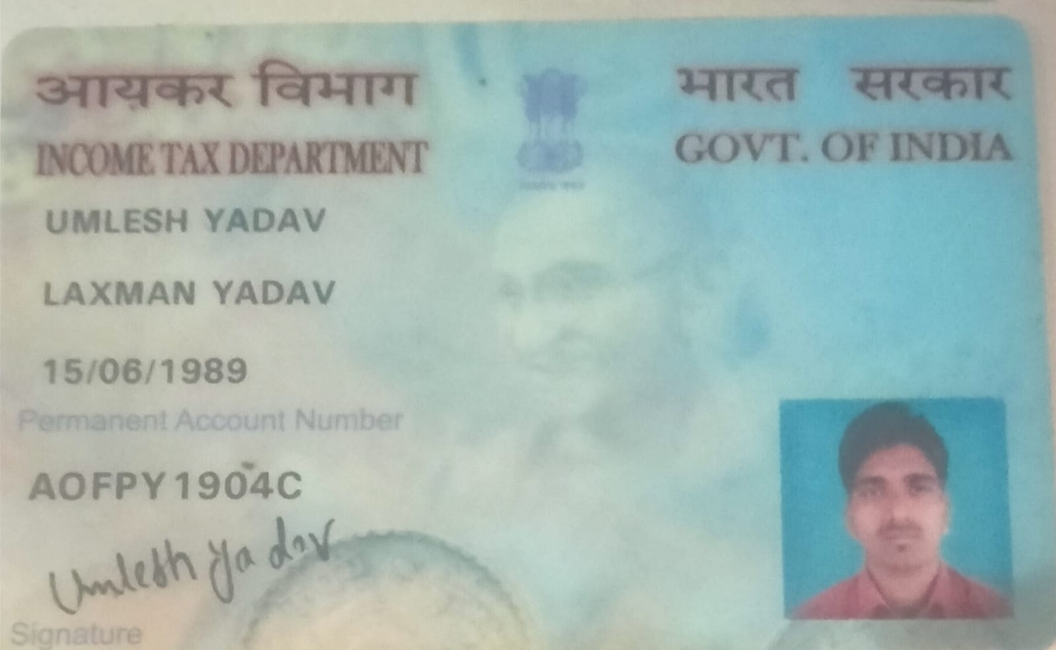
UMLESH YADAV
Candidate's Full Legal Name (as it appears on PAN) | UMLESH YADAV
Supplier Name (Registered Name) | People-Prime Worldwide
Worked for CG previously? (IF yes share CG Employee ID/GGID required) | No
JOB Posting ID | CGEMJP00344372
Contact No (10 Digit No) | 7042112586
Email ID | umleshyadav2012@gmail.com
Job Location (Work Location) | Noida
Notice Period (Immediate/ Notice to Serve) | LWD: 22 June 2026
Highest Education (Regular or Distance) | MCA
Employment Detail – Last 2 yrs Working period (Payroll Company) | EXSL
College & University Full Name - | National Institute of Technology, Agartala
Mandatory Skills & Experience  (quick checklist – verify each skill, years of experience) | Total experience: 8 years  java :6 years  Springboot:5years  Angular 3.5 years  Ngrx:2 years  Rxjs 3 years
“Secondary” Skills & Experience | Total experience: 8 years  java :6 years  Springboot:5years  Angular 3.5 years  Ngrx:2 years  Rxjs 3 years
Key Remarks (Supplier Comment) | Candidate Good at Communication Skill.  He is with 8+Yr of Total experience and Relevant experience in “ Java ”is 6+yr. He has a 5Yr in Springboot .

UMLESH YADAV
Java Full Stack Developer
(+91) 7042112586
Noida, INDIA umleshyadav2012@gmail.com 8 Years 0 Month of experience

 PROFILE SUMMARY  KEY SKILLS






























I have done MCA from National Institute of Technology (NIT), Agartala .Currently working with EXL Service india Pvt Ltd, Greater Noida as Java Full Stack Developer on a position of Program Analyst from 30th May 2022 to present. I am good in Core java ,Spring Boot, Jasper Report Tool, Oracle, Spring Boot,Hibernate, Angular8 ,SQL and J2EE Git , Agile methodologies. My professionals interests are working in Sql with java and ORM Tools like Hibernate and Spring Boot.Now i wanna switch to get better opportunity to get more exposure on both technical and production support side.
Grafana
Gitlab
Core Java
Collection
Multithreading
Hibernate
SQL
Html5
CSS
JSON
MySQL
MyEclipse
Eclipse IDE
J2EE
JIRA
OOPS
Java Web Services
Groovy
Grails
Bitbucket
Jasper Reports
Spring Boot
SVN
Microservices
SQL Stored Procedures
Python
Kafka Messaging
Json / Xml
Maven






 WORK EXPERIENCE
SQL Server
Rest API Design
Exception Handling
Oracle
Chatgpt




Java Full Stack Developer
Copilot
JUnit
Mockito
Angular

Exl Service. com India Pvt Ltd
05-2022 - Present
Java SQL with Spring Boot Developer, Angular, MySQL, Grafana monitoring tools, jira scrum Agile sdlc model.

 CERTIFICATION

Sql for Data Science Basics of Python

Accion Labs
Senior Software Engineer
04-2021 - 05-2022
Java SQL and Jasper Report. I was working as a Java full stack developer as participated on both java and database side alongwith Jasper Report and jsp.

Software Engineer
3i-Infotech
07-2019 - 04-2021
Software Engineer. Worked as a Java developer with SQL and Jasper Report with Spring Boot
Spring Boot

PROJECTS

DDA(Delhi Development Authority)
12 Months
This is Delhi Development Authority project for community hall booking ,housing and Land conversation, personal hearing for meeting scheduled for applicant. Here we created rest API for personal hearing, housing and land conversion with java Spring Boot MySQL and Angular Material to create User interface for data binding and to consume rest API in Frontend

framework and MySQL database and Angular Material to create web pages and for data binding.

Software Engineer
Chetu
02-2018 - 05-2019
worked on groovy and grails framework along with jasper report and sql server database queries to bind the dynamic data to jasper reports.

 INTERNSHIP

Quinstreet Software India
CarInsurance. com, Health insurance. com,
6 Months
Joined as a fresher ,learned Java and php programming and technology .worked as a trainee positions and worked onto 3 project CarInsurance.com, healthinsurance.com and autoinsurance.com and used on html ,css, MySQL, jQuery, php,codeIgniter framework ,Java and j2ee technologies.

 EDUCATION

MCA - Computers 2016
National Institute of Technology, Agartala
Grade - 8.04/10

BCA - Bachelor of Computer Applications - Computer Applications (General)
2011
Indira Gandhi National Open University (IGNOU), Delhi
Grade - 61%

Class XII 2008
Jharkhand, English
Marks - 52%

Class X 2006
Jharkhand, English
side.

Created Angular based web page for data binding using Angular Material.

We have created different Reports for all modules using Jasper Report Java tools to generate PDF for every module.

Export Inspection Of Council (EIC)
10 Months
This project is for export and import of goods in EU(Europian) And non-EU countries .delivery of fish, milk, honey and basmati rice product.

Here we created Rest API using Java Spring Boot MySQL and Angular to consume Rest API at client side.

We developed lots of reports using Jasper and jrxml for Europian and Non- Europian country for lots of export and import products.

For Front Engineer
15 Months
This is a logistics project for yard management system and export, import the dock in the yard. creating gate pass for goods and place goods into the yard or warehouse using yard pilot.

Here we used Groovy script and Grails framework with sql server and created Jasper Report and binded dynamic sql queries data with the corresponding report using jrxml Report tools.

SubroSource
48 Months
- Spearheaded the SubroSource project for MetLife, focusing on the subrogation of property and casualty claims.

- Collaborated with 10 diverse clients to.

streamline claim processes and enhance operational efficiency.

Here I have been using core java, Hibernate, spring Boot, MySQL and Angular Rxjs.

- Developed an integration strategy to facilitate

Marks - 64.4% seamless communication between claim centers and clients.

  - Improved claim turnaround times by implementing best practices in subrogation management, resulting in enhanced client satisfaction.

This project has other main client like Farmers, SHP, Mapfre, AIG, USSA, Allstate, QBE, IAT and SafeAuto

StixCloud
13 Months
  - Developed and maintained robust software solutions for Sistic, enhancing ticketing services for movies, circus, theater, and event management in Singapore.

  - Collaborated on the Jewel Changi Airport project, providing vital software support and enhancements to meet project requirements.

  - Leveraged Java and SQL technologies to design, implement, and optimize backend services, ensuring performance for high-traffic applications.

  - Created and managed dynamic reports using Jasper and JRXML tools, delivering critical insights for business operations and strategic decision-making.

  - Streamlined reporting processes that improved data retrieval efficiency and significantly reduced response times for end users.

  - Participated in code reviews to uphold software quality and maintain best practices in software development.

  - Worked within Agile methodologies and utilized Jira tools for effective project management, alongside GitLab for code version control.

 LANGUAGES

English Hindi

